1)

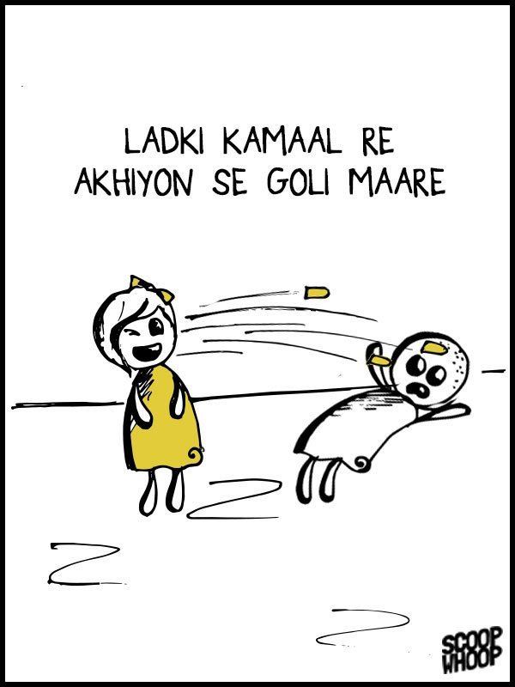

Kya KAMAL Ladki ko Ankho se Goli marna allowed hai?

Why she used eye instead of weapon Is she afraid of police case?

2)

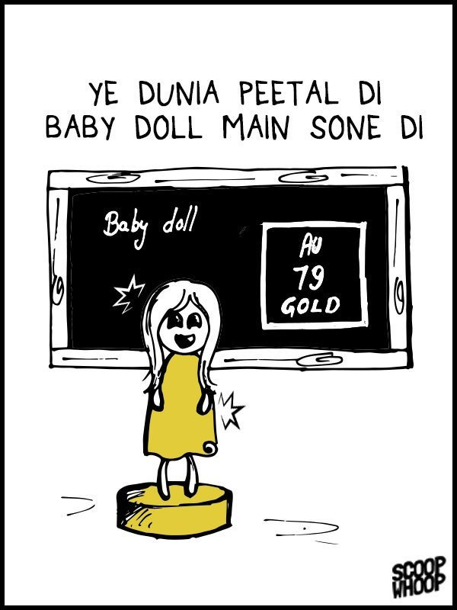

Iss mehangai ke zmane me Ladki ko sona kha se mila?

3)---

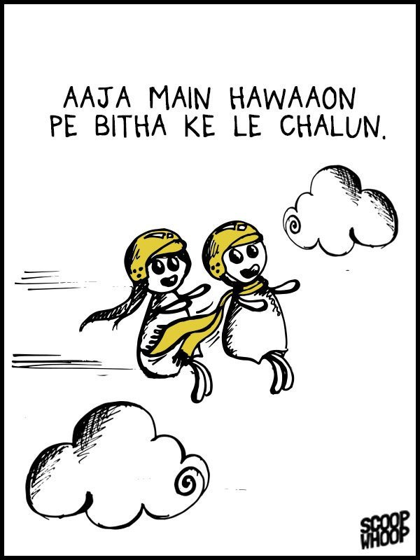

Kya ye badhti meghangai se pareshan tha?

Kya iski gadi ka petrol khatam ho gya tha ya ye starbuks chala gya tha isliye petrol afford ni kr paya?

4)

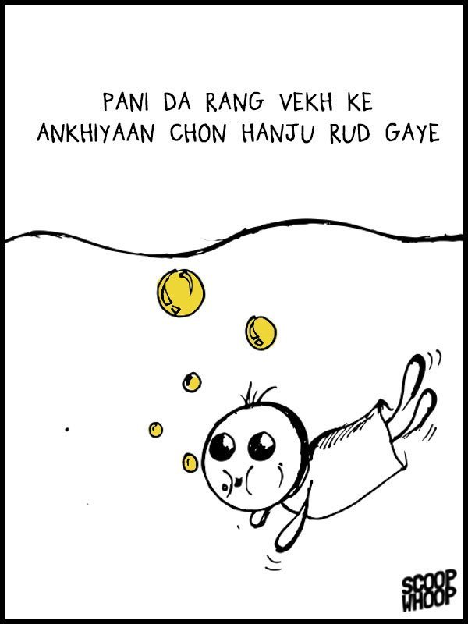

Pani ka rang kya tha jo ansu aa gye?

Pani me asia kya tha jo Isko ansu aye?

5)

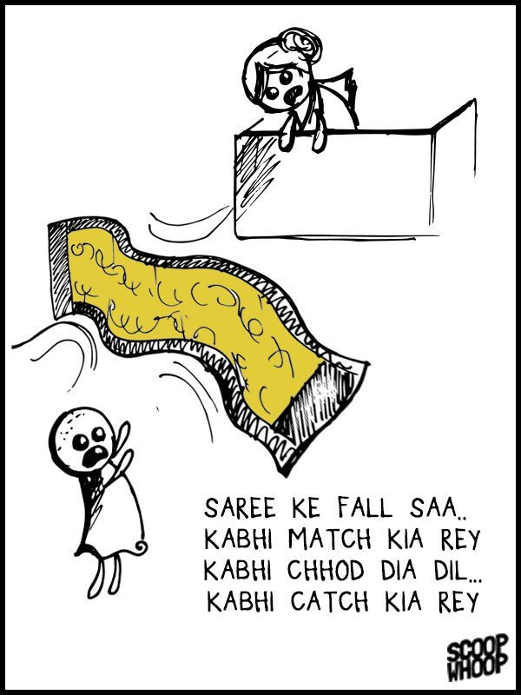

Kya ye Joru ka gulam tha? Jo Ladki dil se catch catch kyu khel rhi hai? Kya iske pas ball nhi thi?

6)

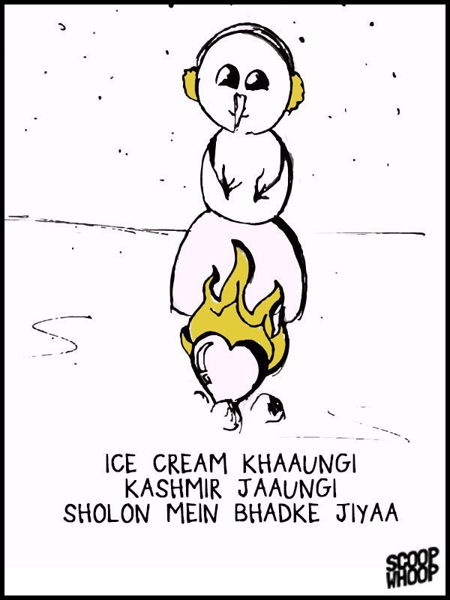

Kya isko delhi ki ice cream pasand nhi ayi thi?

7)

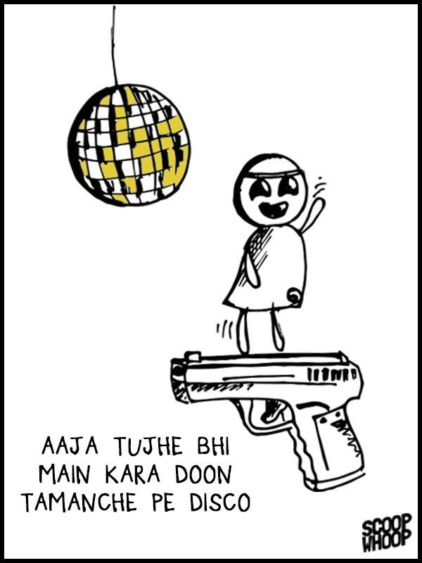

Ye hamari me se kisko disco krana chata hai?

9)

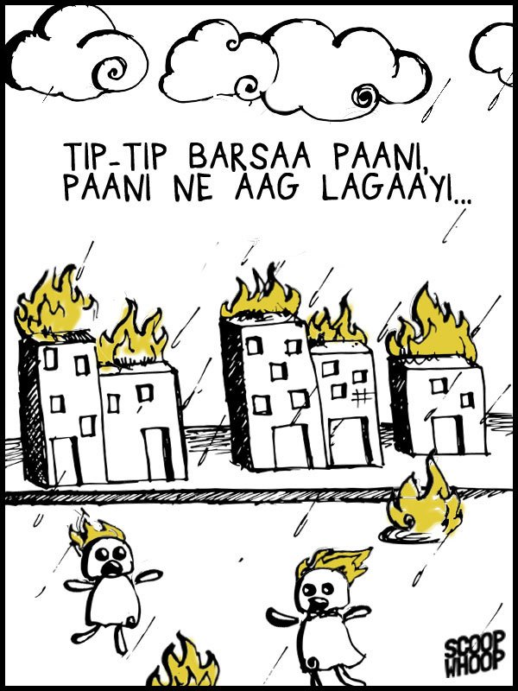

Pani me aag kaise lagi?